**TERMINAL COMMANDS**

* Echo: print the string.



* Pwd: current working directory path.



* ls
* ls ~: gives/jump all file present in system or all home directory

* ls .. : give content or file present in parent directory



* ls . : List files and folder in current directory



* ls -a : list all files and folder including hidden one



* ls -al : list all files and folder including hidden one in long format

* ls -l : list files and folder in long format



* ls -p :give all files in current directory



* ls -p | grep pdf :gives if any pdf file is present (you can write whatever type of file in place of pdf like txt n all)

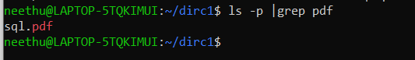

* mkdir
* mkdir directory_name : create directory



* rmdir dire_name : removes that particular directory

* mkdir -p directory_name1/directory_name2 : create nested directory

* cd
* cd directory_name/ : take u to that directory



* cd .. : take u to one directory before



* cd - : take u to previous working directory



* touch
  + touch file_name : create empty file

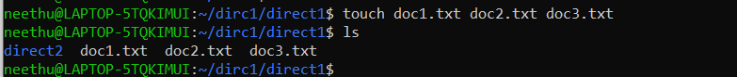

* rm
  + rm -r file_name : deletes that perticular file_name

* + rm -i file_name : ask user permission before deletion

* + rm -I file_name : dosnt ask user before deletion

* + rm -r directory_name: remove the directory recursively

* + rm -ir directory_name : removes the file or dir with asking permission

* CP & MV
  + cp file_parent file_child : copy content of parent on child

* + mv file_parent file_child : move content of parent on child

